Use this guide to understand the Financial Aid Period Record (FAPR).

HIGHLIGHTS
- The information in a student’s Academic > Overview tab as of the standard start date of a particular period is reflected in the Financial Aid Period Record for the same corresponding period.

In this example, the student changed their primary program of study (POS) from History to Biology in May 2024. This change occurred before the standard start date for the Summer 2024 period, therefore, this change is also reflected in the Financial Aid Period Record for the Summer 2024 period.

Note: If this change occurred after the standard start date for the Summer 2024 period, it would not be reflected in the Financial Aid Period Record.

Academic > Overview tab
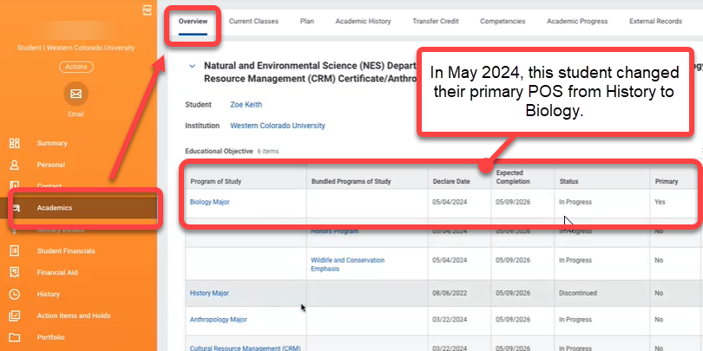

Financial Aid Period Record
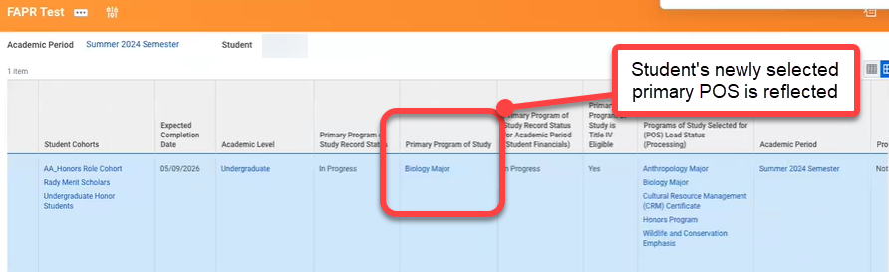

- In order for registered courses to count towards the student’s major, they must be backdated before the standard start date.

- Be aware there is an error with three columns:

- Registered Courses
- Registered Course Count
- Course Start (POS) Hours from Selected Registered or Completed Developmental Courses

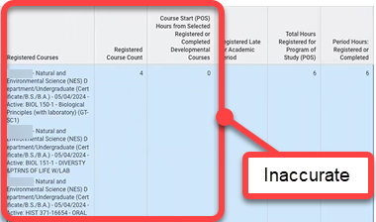

A bug is submitted to remedy.

